ACI Assignment 2

Course: Artificial and Computational Intelligence

PEAS Environment for the problem:
<Copy of the same contents present in python notebook is added here>

Performance Measure:
- Winning the Game: The primary performance measure is winning the game by capturing all of the opponent's pieces.
- Minimizing Moves: Secondary performance measure could be minimizing the number of moves to win the game.
- Avoiding Loss: Ensuring that the agent does not lose the game by protecting its own pieces.

Environment:
- Game Board: A 3x3 grid representing the game state.
- Pieces: Different types of pieces (e.g., Soldier, Horse, Elephant) for both players.
- Turns: Alternating turns between the user and the AI.
- Rules: Movement rules for each type of piece and conditions for winning or losing the game.

Actuators (O/P):
- Move Pieces: The ability to move pieces on the board according to the rules of the game.
- Capture Pieces: The ability to capture opponent's pieces by moving to their position.

Sensors (I/P):
- Board State: The current configuration of pieces on the board.
- User Input: The moves entered by the user.
- Game Status: Information about whether the game is ongoing, won, lost or draw.

Screenshot of the Output:

- First player is User (white) and User wins (Part A)
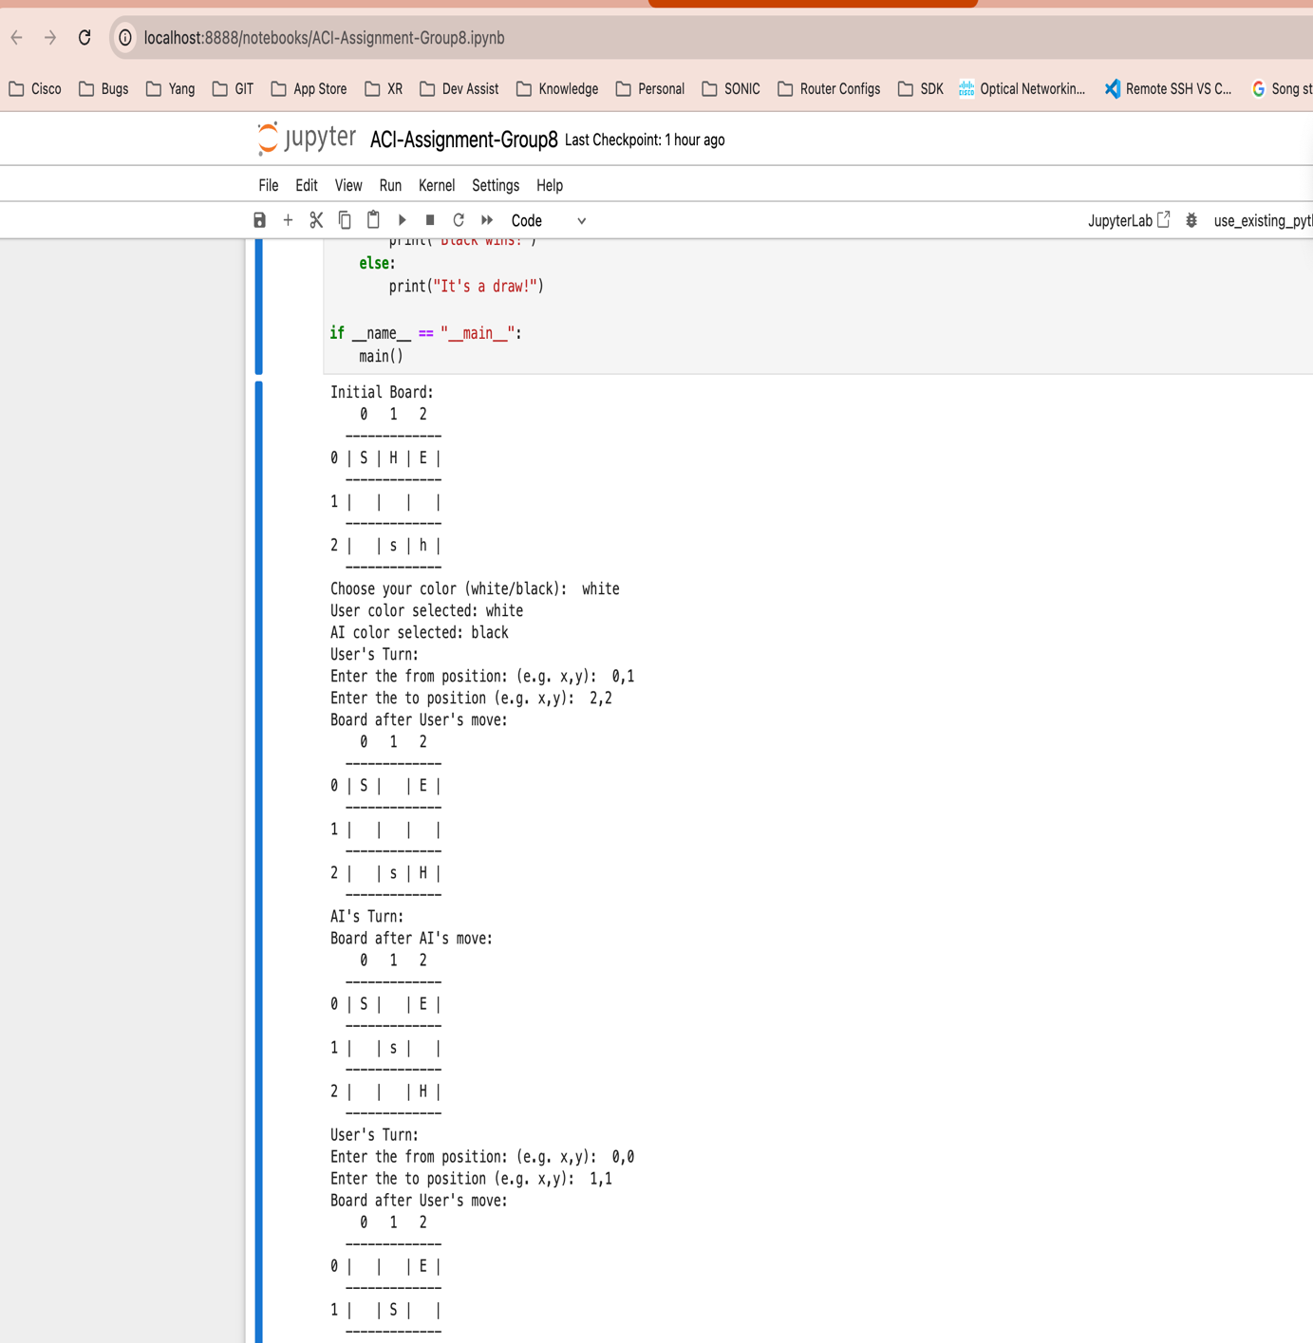

- First player is User (white) and User wins (Part B)
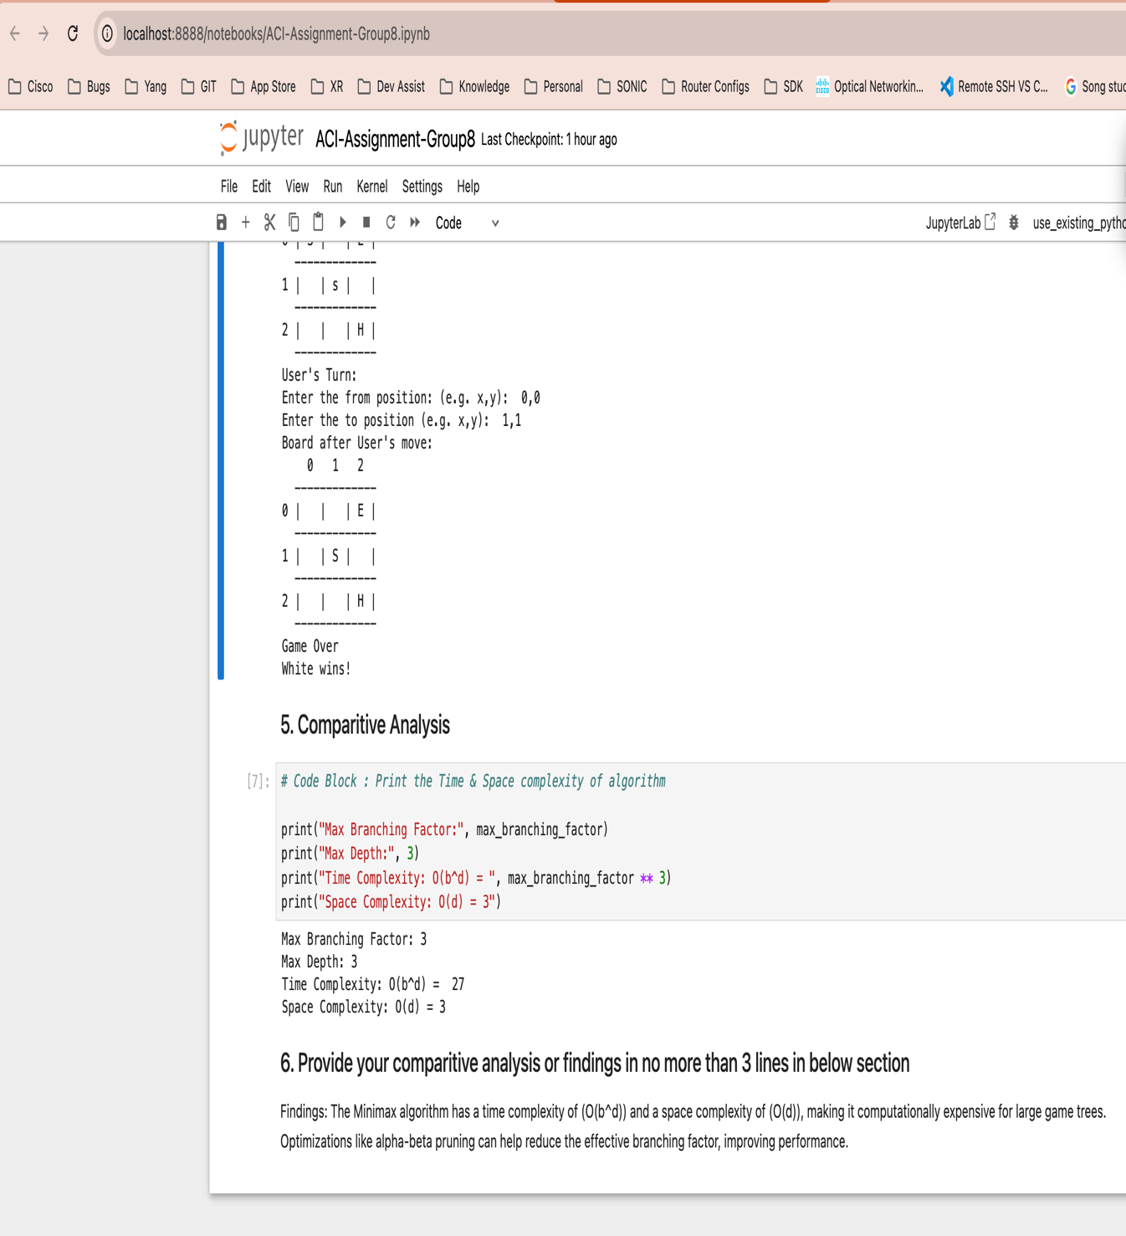

- First player is AI (White) and AI wins (Part A)
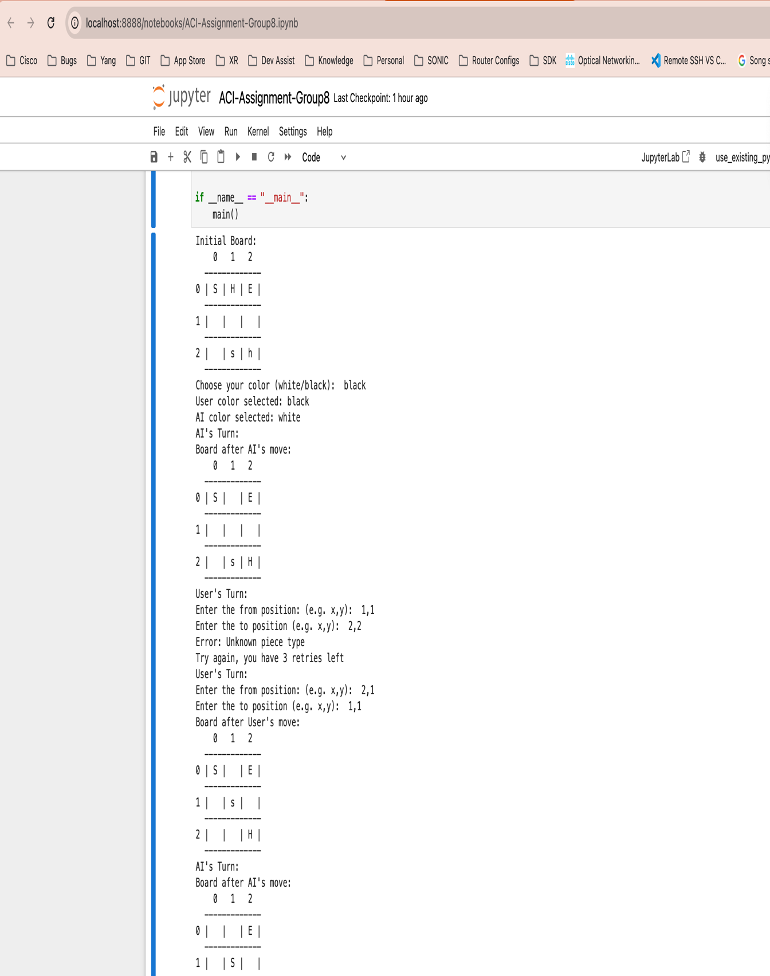

- First player is AI (White) and AI wins (Part B)
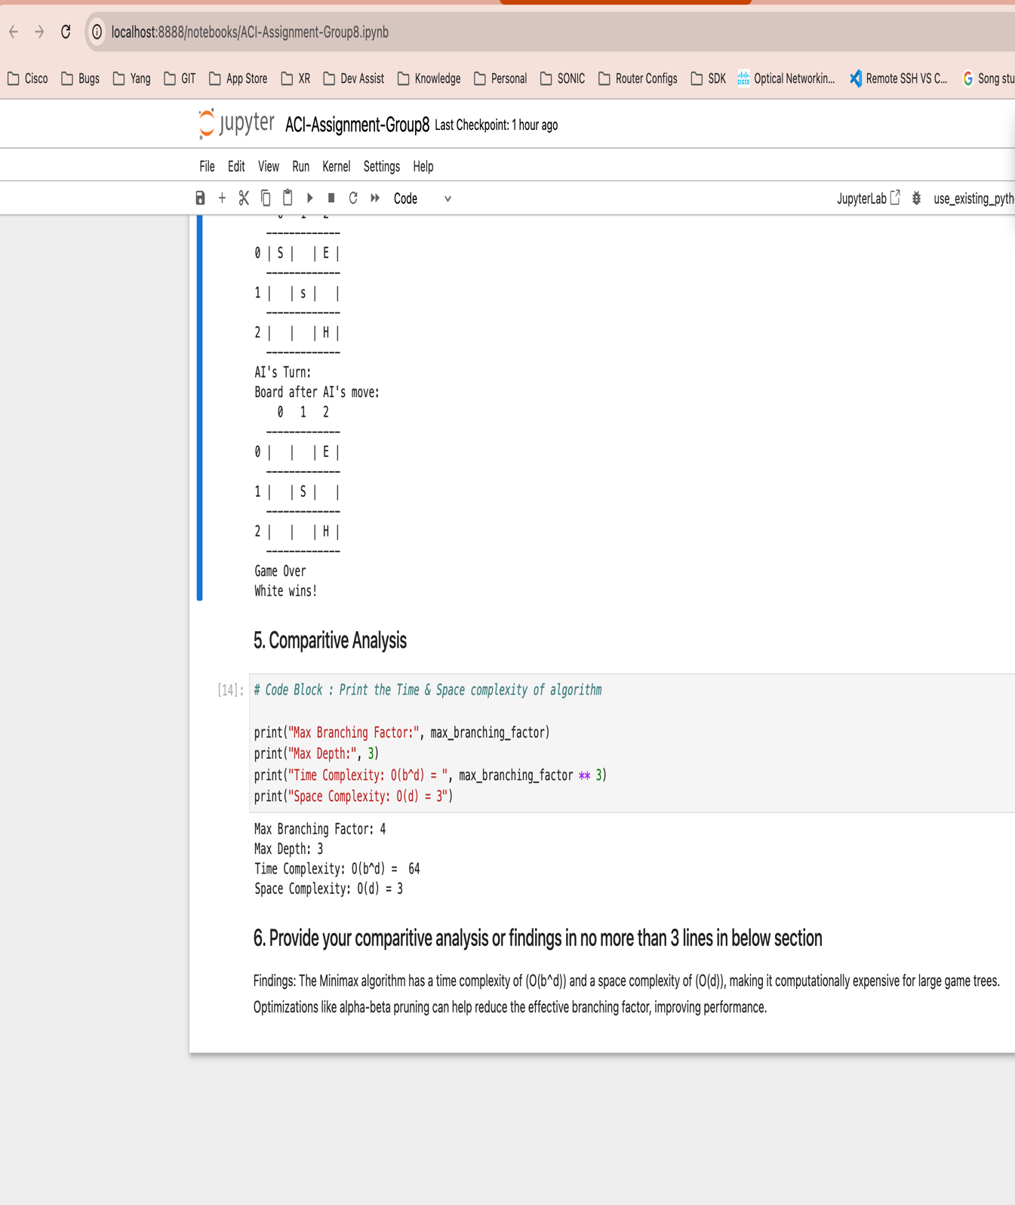

- Draw Match (Part A)
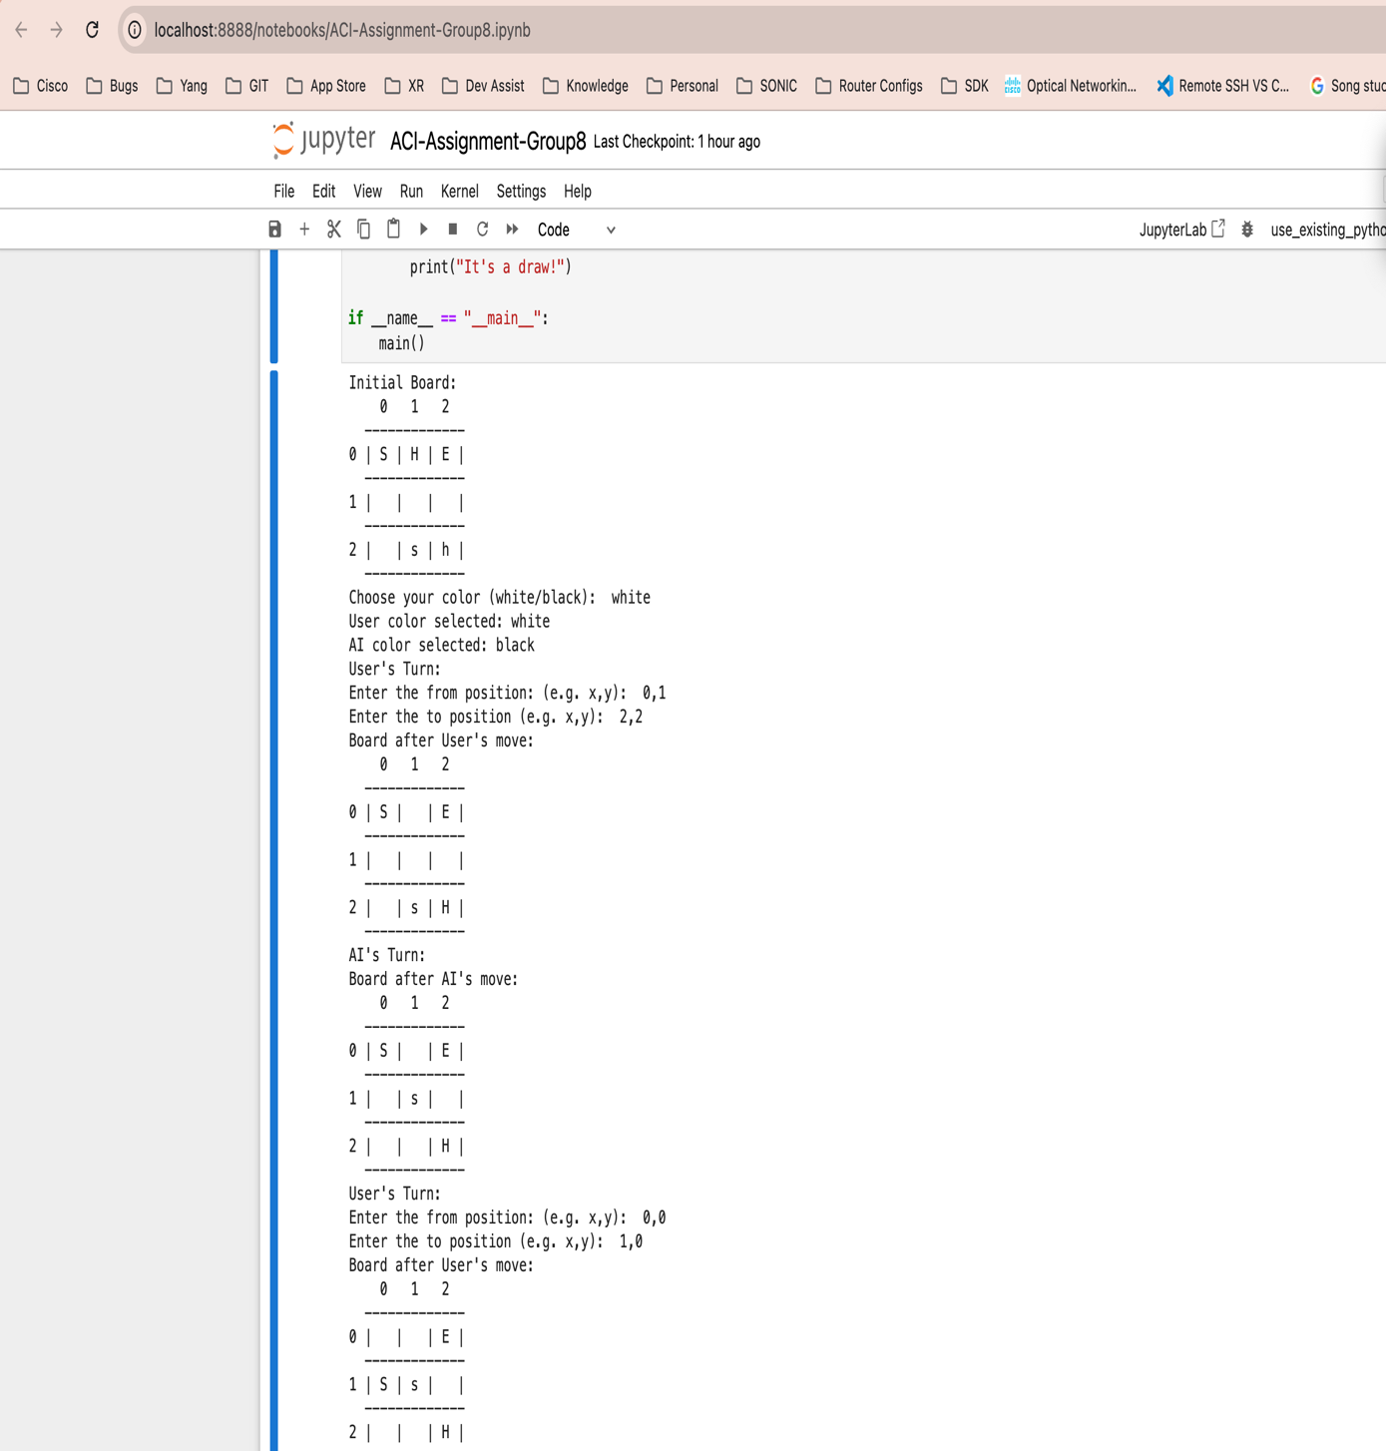

- Draw Match (Part B)
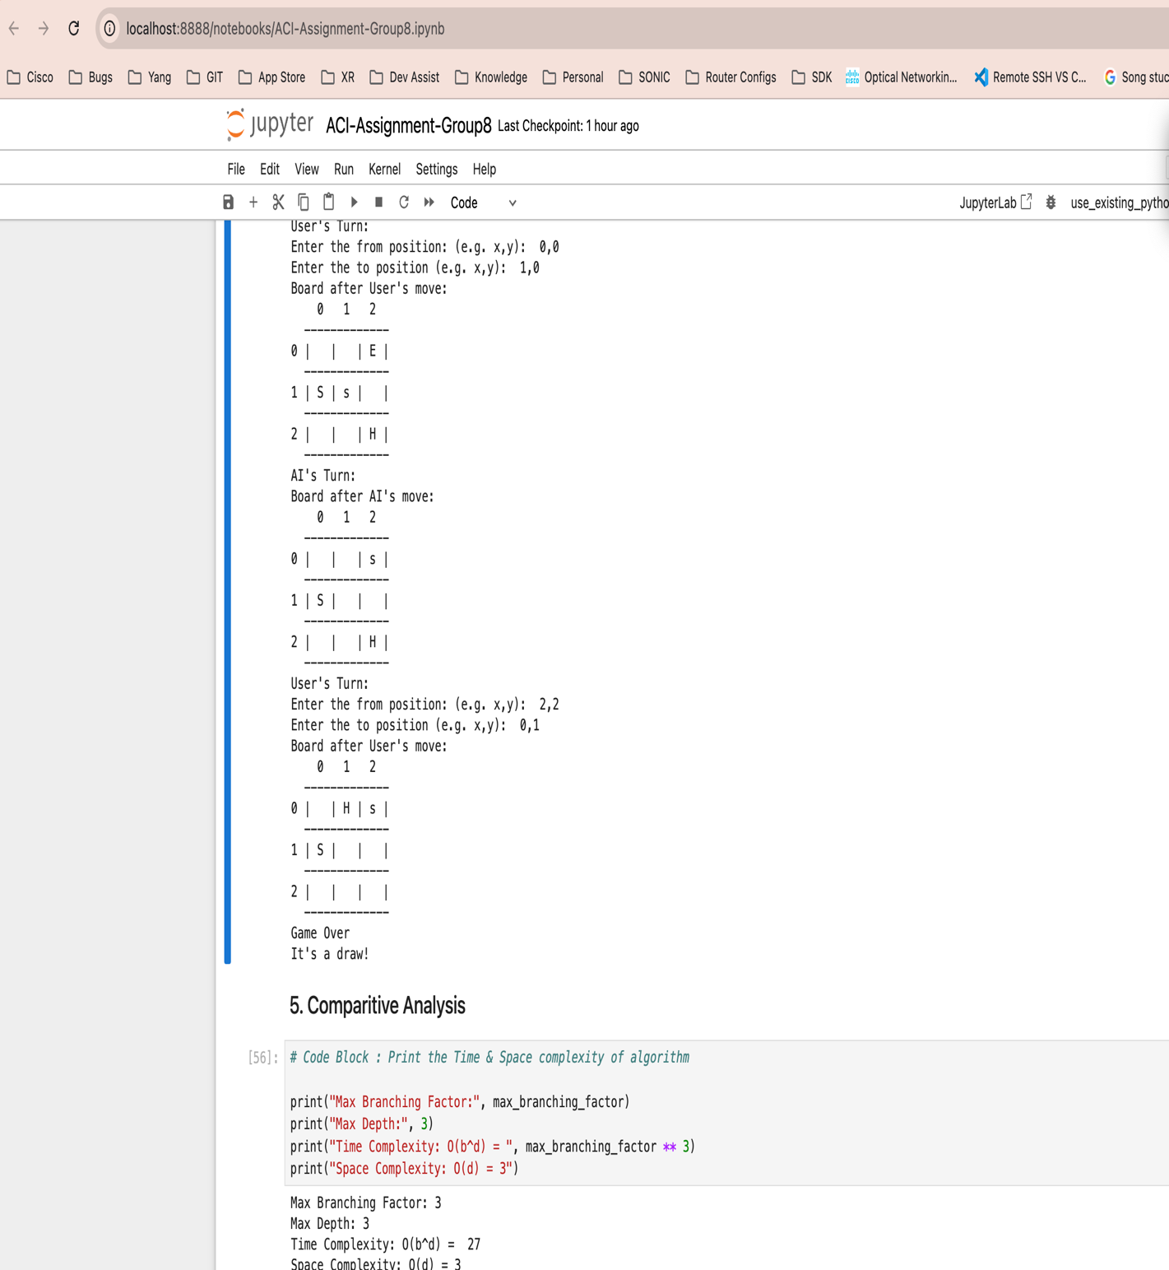

Other details:

- Assumptions: As per the Chess rule, we have considered white is the first player to move.
- Python notebook attached has the outputs included.
- Attached PDF has detailed explanation of the algorithm.

